
Flight Price Prediction and Flight Fare Classification using Machine Learning
Mini Project Report
Submitted By: Debasruti Gope (25122007) & Pawar Abhishek Kishor (25122015)
Course: Regression Modelling and Machine Learning
University: CHRIST (Deemed to be University)
Submission Date: 26 May 2026

INTRODUTION
Problem Statement
The airline industry experiences continuous fluctuations in ticket prices due to factors such as flight duration, airline company, number of stops, departure timing, destination, and remaining days before departure. Accurate prediction of flight fares can help passengers make better booking decisions and assist airline companies in pricing analysis and revenue management.
The objective of this project is to develop machine learning models for both regression and classification tasks. The regression models are used to predict flight ticket prices, while classification models are used to categorize flights as expensive or non-expensive based on fare values.
The project includes complete data preprocessing, exploratory data analysis, feature engineering, regression assumption testing, feature selection, model building, model evaluation, overfitting analysis, and model improvement using real-world airline data.
Various machine learning algorithms including Multiple Linear Regression, Ridge Regression, Lasso Regression, Logistic Regression, Support Vector Machine (SVM), Naive Bayes, Decision Tree, and Random Forest are implemented and compared to identify the best-performing models for flight fare prediction and classification.

Dataset Information
- Dataset Name: Flight Price Prediction Dataset
- Source: Kaggle
- Type: Real-world airline dataset
- Number of Observations: Approximately 10,000 rows
- Features Included: Airline, source city, destination city, departure time, arrival time, duration, number of stops, class, days left, and other flight-related attributes
- Target Variables:
  - price → Used for Regression Analysis
  - Expensive_Flight → Used for Classification Analysis
- Project Objective: To perform flight price prediction and fare classification using statistical regression techniques and multiple machine learning algorithms.

Data Understanding
- The dataset was loaded using the Pandas library and the first five rows were displayed to understand the structure of the data. The dataset contains flight-related information such as airline, source city, destination city, duration, class, and ticket price.
- Initially, the dataset contained 300,153 rows and 12 columns. To reduce computational complexity, a random sample of 10,000 observations was selected for analysis and modelling.
- The df.info() and df.dtypes functions were used to examine the structure and datatype of each variable. The dataset contains both categorical and numerical variables.
- Missing value analysis using df.isnull().sum() showed that there were no missing values in the dataset.
- Duplicate value analysis using df.duplicated().sum() confirmed that there were no duplicate rows present.
- Descriptive statistics were generated using df.describe() to understand the distribution of numerical variables such as duration, days left, and price.
- The average flight duration was approximately 12.24 hours, while the average ticket price was around 21,010 INR. The large difference between minimum and maximum prices indicates high variability in flight fares.
Variable Description
Variable | Description | Type
airline | Airline company name | Categorical
flight | Flight number/code | Categorical
source_city | Departure city | Categorical
departure_time | Departure timing | Categorical
stops | Number of stops | Categorical
arrival_time | Arrival timing | Categorical
destination_city | Destination city | Categorical
class | Travel class | Categorical
duration | Flight duration (hours) | Continuous
days_left | Days left before departure | Continuous
price | Flight ticket price | Continuous (Target)

Screenshots:


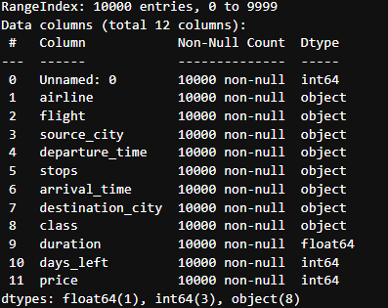
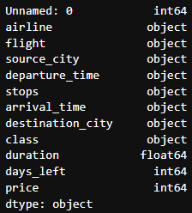
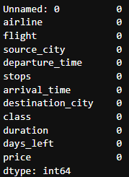

Exploratory Data Analysis (EDA)
Histogram Analysis
- Histograms were plotted for the numerical variables to study their distribution patterns.
- The duration variable is slightly right-skewed, indicating that most flights have shorter durations.
- The days_left variable shows an almost uniform distribution across different booking days.
- The price variable is highly right-skewed, showing that most ticket prices are low while a few flights have very high fares.
- The distribution of price suggests the presence of outliers and high variability in flight fares.
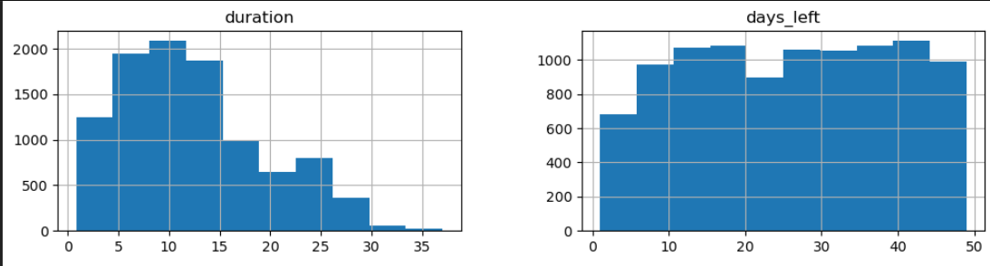
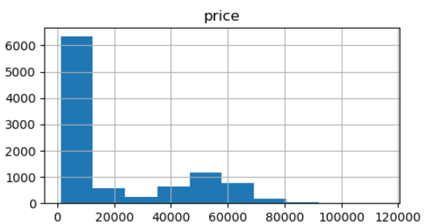

Insights from the Boxplots
Duration
- Most values are between 7 and 16.
- Median is around 11.
- Distribution is right-skewed.
- Several high-value outliers exist above 30.
- Most flights have shorter durations, while a few take much longer.
Days_left
- Values are spread evenly from 1 to 49.
- Median is around 25.
- No major outliers are visible.
- Distribution appears balanced and symmetric.
- Booking days are well distributed without unusual extremes.
Price
- Prices have a large spread.
- Median price is relatively low compared to maximum values.
- Distribution is highly right-skewed.
- A few very expensive tickets appear as outliers above 100,000.
- Most prices are concentrated in the lower range.
Overall Results
- Duration and Price contain noticeable outliers.
- Price has the highest skewness and variability.
- Days_left is the most stable variable.
- Outliers in price and duration may affect machine learning models and may require treatment such as removal, capping, or transformation.
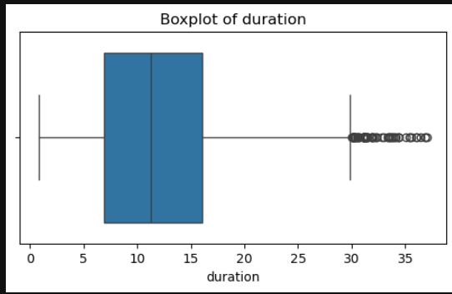
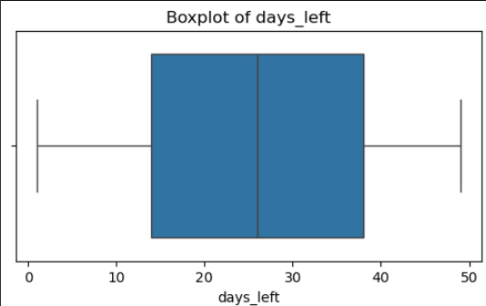
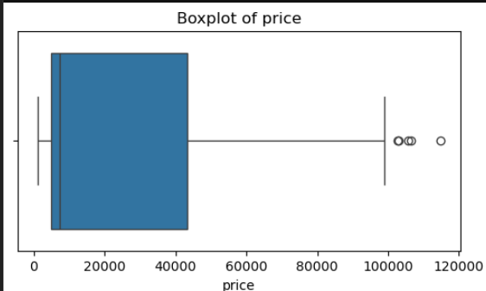
Skewness of numerical columns
The skewness results indicate how symmetric or asymmetric each numerical feature is:
- duration → 0.59
  - Moderately positively skewed (right-skewed)
  - Distribution has a longer right tail
  - Usually acceptable for many ML models
- days_left → -0.03
  - Very close to 0
  - Almost perfectly symmetric / normally distributed
- price → 1.07
  - Stronger positive skewness
  - Indicates some high-price outliers or a long right tail
  - Often benefits from transformation

Distribution & Skewness Analysis
duration
- Right-skewed distribution.
- Most flights last between 5–15 hours.
- Few very long flights create outliers.
- Indicates presence of short, medium, and long-haul flights.
days_left
- Nearly symmetric / evenly distributed.
- Bookings happen across different time periods.
- No strong skewness observed.
price
- Highly right-skewed distribution.
- Most ticket prices are in the lower range.
- Few expensive tickets create a long right tail.
- Possible premium/business-class pricing cluster around higher values.
Overall Insights
- duration → moderately skewed.
- days_left → low skewness.
- price → strongly skewed with outliers.
- Median is better than mean for analyzing price.
- Log transformation may help improve price distribution for ML models.
Distribution Plot
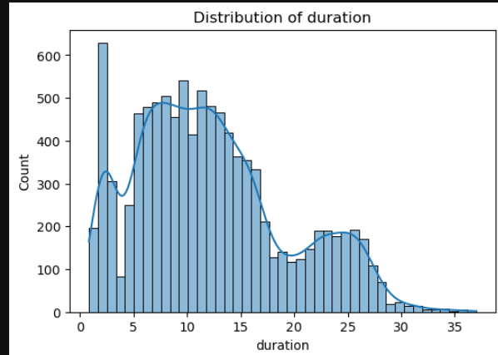
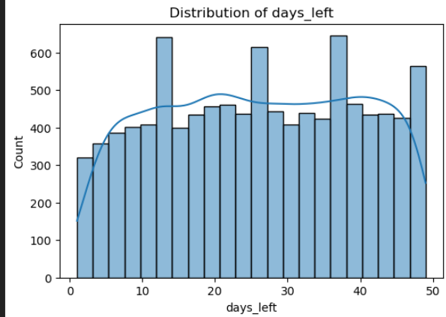

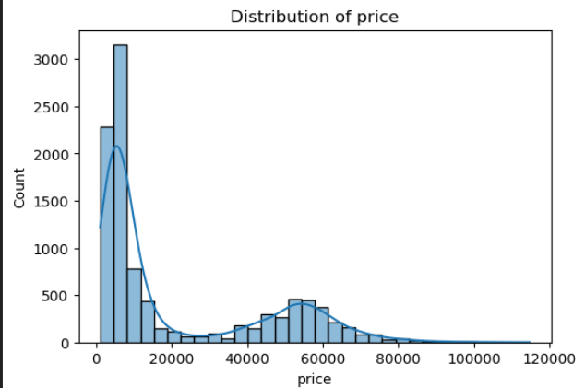

* The duration variable shows moderate positive skewness with most observations concentrated between 8 and 16 hours. A smaller secondary peak around 22–26 hours suggests multiple clusters of flight durations, while the long right tail indicates the presence of a few unusually long-duration flights.
* The days_left variable exhibits an approximately uniform and symmetric distribution, indicating that flight bookings are evenly spread across different advance booking periods.
* The price variable shows a highly positively skewed bimodal distribution with two distinct price clusters. This likely reflects separation between economy and premium-class ticket pricing. The long right tail indicates extreme high-price observations, justifying log transformation for regression modelling.
The distribution plots reveal that duration is moderately right-skewed with multiple clusters, days_left is approximately uniformly distributed, and price is highly positively skewed with a bimodal structure.
The bimodal price distribution likely reflects class-based fare segmentation, while the extreme right tail confirms the presence of premium-priced outliers. This supports the application of log transformation to improve regression assumptions and stabilize variance.

Relationship Between Flight Duration and Price
A scatterplot was created to examine the relationship between flight duration and ticket price.
The graph indicates a generally positive relationship, suggesting that longer flights tend to have higher ticket prices.
This visualization also helps assess the linearity assumption required for linear regression.

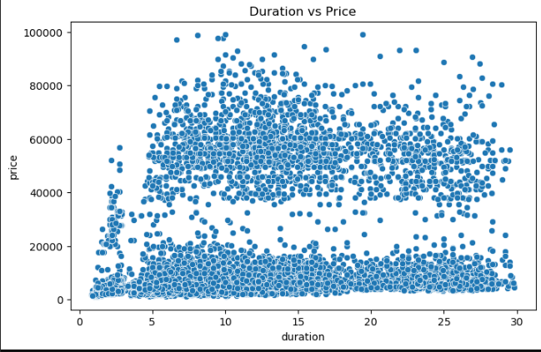

Correlation Heatmap Analysis
- The heatmap shows the correlation between duration, days_left, and price.
- Correlation values range from -1 to +1:
  - +1 = strong positive correlation
  - -1 = strong negative correlation
  - 0 = no correlation
- Duration and price have a weak positive correlation (0.22), meaning longer flights may cost slightly more.
- Days_left and price show a weak negative correlation (-0.10), suggesting prices may reduce slightly when booked earlier.
- Duration and days_left have almost no correlation (-0.035).
- No strong correlations are present, indicating price depends on multiple factors.
- Red shades represent positive correlation, while blue shades represent negative correlation.
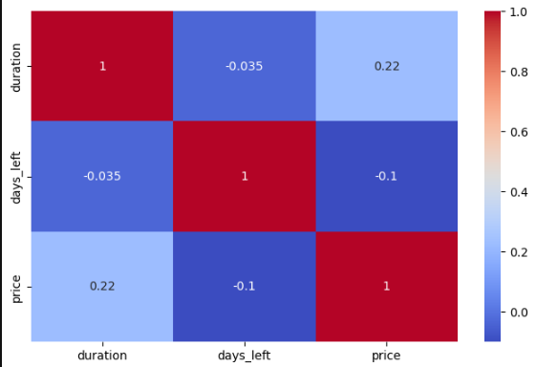
Airline Distribution Analysis
- The chart shows the number of flights operated by each airline.
- Vistara has the highest number of flights in the dataset.
- Air India and IndiGo also have a significant presence.
- SpiceJet and AirAsia have comparatively fewer flights.
- The dataset is slightly imbalanced, with some airlines appearing much more frequently than others.
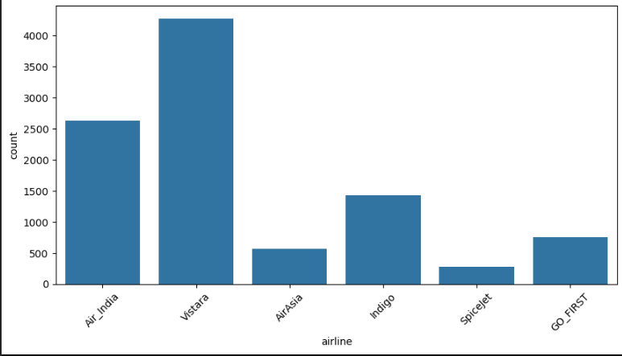

Data Preprocessing
Dropping Unnecessary Columns
- The columns Unnamed: 0 and flight were removed from the dataset using drop().
- Unnamed: 0 is usually an unwanted index column created during data export/import.
- flight was removed because it may not contribute significantly to analysis or model training.
- After dropping the columns, the dataset contains 10 useful features.
- The remaining columns include airline details, journey information, flight duration, days left for booking, and ticket price.
- This step helps in cleaning the dataset and reducing unnecessary data before further analysis or machine learning.
Outlier Treatment Using IQR Method
Since the numerical variables showed moderate to high skewness, particularly the ticket price variable, the Interquartile Range (IQR) method was selected for outlier treatment.
The IQR method is more suitable for skewed distributions because it is robust to extreme values and does not assume normality.
Outliers were removed to improve regression stability, reduce noise, and help satisfy linear regression assumptions.
Impact of Outlier Treatment
After applying IQR-based trimming, only 76 observations were removed from the sampled dataset of 10,000 rows.
This represents approximately 0.76% of the dataset, indicating that the data contained relatively few extreme observations.
Since the percentage of removed records was very small, the integrity and overall distribution of the dataset remained largely unaffected.

Feature Engineering
A new binary classification variable named Expensive_Flight was created using the median flight ticket price.
Flights with prices greater than the median were classified as expensive, while flights below the median were classified as affordable.
This transformed the project into a classification problem suitable for Logistic Regression and other classification algorithms.
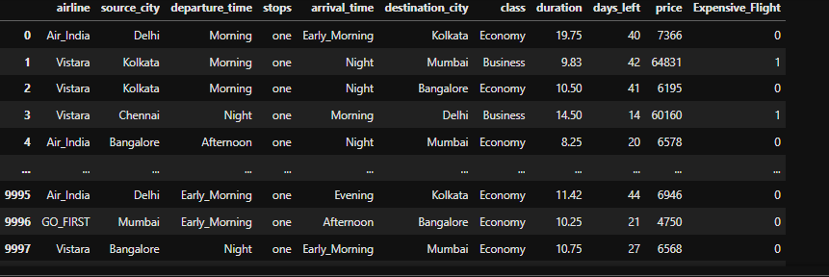
One-Hot Encoding
- Converts categorical columns (airline, city, class, etc.) into numeric binary columns (True/False or 1/0).
- Each new column represents one category.
  - Example: airline_Air_India = True means the flight is by Air India.
- drop_first=True removes one category from each feature to avoid multicollinearity (dummy variable trap).
- The dataset becomes suitable for Machine Learning models because models work with numbers, not text.

- Every row now contains:
  - Numerical features → duration, days_left, price
  - Encoded categorical features → airline, source city, class, etc.
- Expensive_Flight appears to be the target/output variable (0 = not expensive, 1 = expensive).
- Insights possible after encoding:
  - Which airlines increase ticket price
  - Whether Business/Economy class affects expense
  - Impact of stops, timing, and cities on price
- Result:
  - Clean structured dataset ready for training ML models like Logistic Regression, Decision Trees, Random Forest, etc.
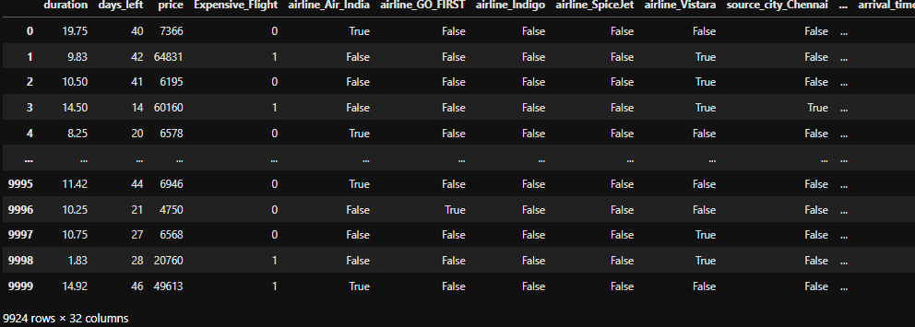
Target Variable Definition
The target variables were defined separately for regression and classification tasks.
For regression analysis, the target variable was selected as Price, which represents the flight fare.
For classification analysis, the target variable was defined as Expensive Flight, a binary variable indicating whether a flight is expensive or not.
This separation allows the implementation of both predictive regression modelling and classification modelling on the same dataset.
Feature Selection
The predictor variables were selected by removing the target variables from the dataset. This step ensures that no target leakage occurs during model training and evaluation.
The selected independent variables include flight-related attributes such as duration, days left before departure, airline information, source and destination cities, departure and arrival timings, number of stops, and travel class.
These features are used to capture the important factors influencing flight pricing.
Train-Test Data Splitting
The dataset was divided into training and testing sets using an 80:20 ratio.
- Training Set (80%): Used for model learning and parameter estimation.
- Testing Set (20%): Used to evaluate model performance on unseen data.
This division ensures proper validation of the model’s generalization ability and helps identify overfitting.
Feature Scaling
Feature scaling was performed using StandardScaler.
Standardization transforms the data such that:
- Mean = 0
- Standard Deviation = 1
This step is necessary because machine learning algorithms such as Linear Regression, Logistic Regression, Support Vector Machine, and Perceptron are sensitive to differences in feature scales.
Scaling improves training efficiency and ensures fair contribution of all predictor variables.
Initial Regression Model (Before Improvement)
Purpose:
- Build the first basic regression model
- Check initial performance
- Detect problems (heteroscedasticity, skewness)
Improved Regression Model (After Log Transformation)
Purpose:
- Improve model after finding assumption violations
- Rebuild model with transformed target
- Check improved assumptions
Regression Modelling
Initial Linear Regression Model
An initial Linear Regression model was developed to predict flight ticket prices using the selected independent variables.
The model was trained using the training dataset to estimate the relationship between flight-related factors such as airline, duration, number of stops, source and destination city, departure and arrival timing, and travel class with the target variable price.
The generated predictions were used to evaluate model performance and verify whether the assumptions of linear regression were satisfied.
Model Performance Evaluation
The performance of the initial regression model was evaluated using the following error metrics:
- Mean Absolute Error (MAE): Measures average prediction error.
- Mean Squared Error (MSE): Penalizes larger prediction errors more heavily.
- Root Mean Squared Error (RMSE): Represents error in original target units.
- R-squared (R²): Measures the proportion of variance explained by the model.
These metrics provided an overall assessment of prediction accuracy.
Residual Analysis
Residuals were calculated as the difference between actual and predicted flight prices.
Residual analysis is essential for validating regression assumptions including:
- Linearity
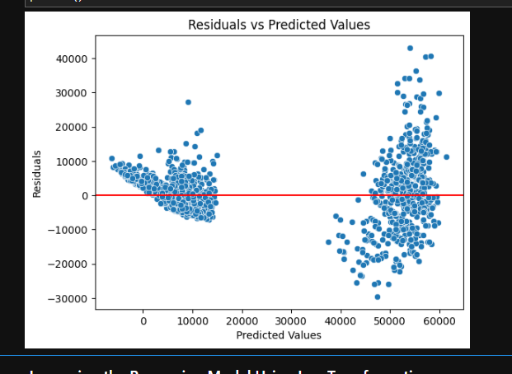
- Homoscedasticity
- Normality
- Independence of residuals
The residual plots indicated that the initial model showed heteroscedasticity, where residual spread increased for larger predicted values.
This suggested violation of the constant variance assumption.
Log Transformation for Model Improvement
The initial analysis showed that the target variable price was positively skewed with extreme high-value observations.
To stabilize variance and improve normality, a logarithmic transformation was applied:
log_price = log(price)
This transformation reduces the influence of extreme values and improves the suitability of the data for linear regression modelling.
The transformed target variable log_price was then used to rebuild the regression model.

Feature and Target Redefinition
After transformation, log_price was selected as the new target variable for regression modelling.
The original price and transformed log_price columns were excluded from the predictor set to prevent data leakage during model training.
This ensured that the model learned relationships only from independent explanatory variables.
Train-Test Split
The dataset was divided into:
- 80% Training Data
- 20% Testing Data
The training set was used for model fitting, while the testing set was used to evaluate predictive performance on unseen observations.
This division ensures unbiased model validation.
Feature Scaling
Feature scaling was performed using StandardScaler.
Standardization transformed all features to:
- Mean = 0
- Standard Deviation = 1
This improves numerical stability and prevents variables with larger scales from dominating the model.
Improved Linear Regression Model
A new Linear Regression model was trained using the standardized predictors and the log-transformed target variable.
This improved model was expected to produce more reliable coefficient estimates and better satisfy regression assumptions.
Residual Plot Analysis After Transformation
The residual plot after log transformation showed a more stable and balanced spread of residuals around zero.
Compared to the initial model:
- Residual variance became more consistent
- No strong systematic pattern was observed
- Homoscedasticity improved significantly
This indicates better model fit and improved linearity assumption satisfaction.
Residual Distribution Analysis
The residual histogram displayed an approximately bell-shaped distribution centered around zero.
This suggests that residuals are reasonably normally distributed, supporting the normality assumption of linear regression.
The logarithmic transformation successfully reduced skewness and improved residual behavior.
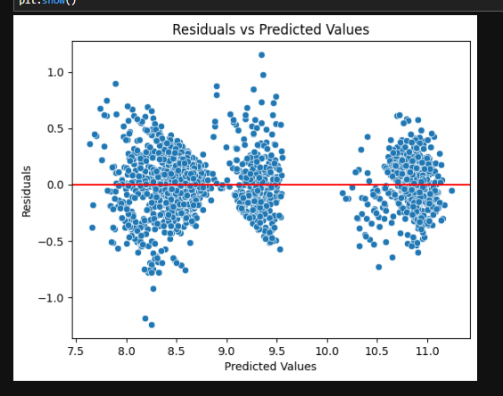
QQ Plot Analysis
The QQ plot showed that most residual points closely followed the reference straight line.
This indicates approximate normality of residuals.
Although slight deviations were visible at the tails, the overall alignment supports the validity of the normality assumption.
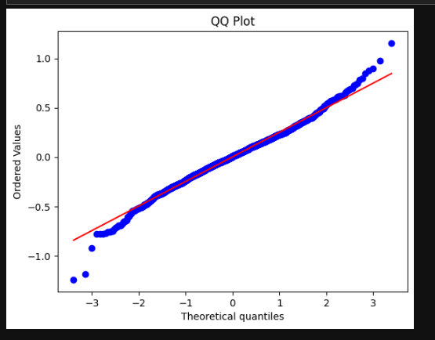
Mean of Residuals
The mean residual value was approximately zero.
This confirms that the model predictions are unbiased on average and satisfies the assumption:
E(error) = 0
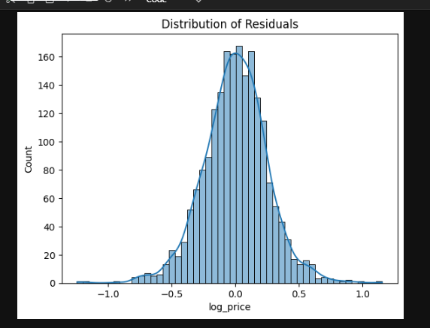
Durbin-Watson Test for Independence
The Durbin-Watson statistic obtained was approximately 2.077.
Since values close to 2 indicate absence of autocorrelation, this confirms that residuals are independent.
Thus, the independence assumption was satisfied.
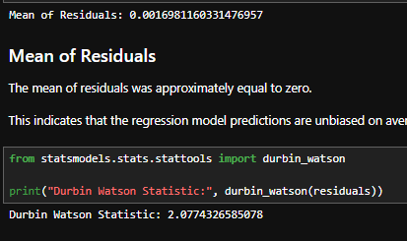
Multicollinearity Check Using VIF
Variance Inflation Factor (VIF) analysis was conducted to detect multicollinearity among predictors.
All VIF values were below the critical threshold of 10, indicating no severe multicollinearity issue.
Although some airline-related variables showed moderate correlation, the overall multicollinearity level remained acceptable for regression modelling.
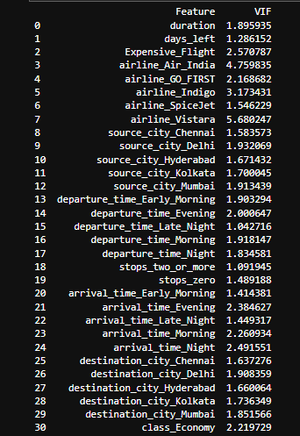
Endogeneity Assumption
The regression model assumes that predictor variables are not correlated with the error term.
Since the dataset consists of independently collected flight booking observations and the predictor variables were selected based on domain relevance, no major evidence of reverse causality or omitted variable bias was identified.
Therefore, the absence of endogeneity assumption was considered reasonably satisfied.
Conclusion of Regression Assumption Testing
After applying log transformation and re-evaluating model assumptions:
- Linearity was reasonably satisfied
- Homoscedasticity improved substantially
- Residuals were approximately normally distributed
- Residual independence was confirmed
- Multicollinearity remained within acceptable limits
- No major endogeneity concerns were observed
Thus, the improved Linear Regression model was considered statistically valid for predicting flight ticket prices.
Multiple Linear Regression (MLR)
Description
- Multiple Linear Regression was used to predict flight ticket prices using multiple independent variables such as airline, duration, stops, class, and journey details.
- The model establishes a linear relationship between input features and the target variable (price / log_price).
- Before model building, data preprocessing steps such as encoding, scaling, outlier treatment, and log transformation were applied to improve model performance.
- Log transformation was especially useful in reducing skewness and improving regression assumptions.
Insights
- The model showed a strong relationship between flight-related features and ticket prices.
- Residual analysis indicated that the log-transformed model performed better than the initial model.
- Residuals were approximately normally distributed, satisfying regression assumptions.
- The Durbin-Watson test value was close to 2, indicating no major autocorrelation issues.
- The difference between training and testing R² was small, suggesting that the model generalized well and was not significantly overfitting.
Brief Output Explanation
- R² Score → Measures how well the model explains variations in flight prices. Higher values indicate better prediction performance.
- Adjusted R² → Improved version of R² that considers the number of predictors used in the model.
- MAE (Mean Absolute Error) → Average absolute difference between actual and predicted prices.
- RMSE (Root Mean Squared Error) → Measures prediction error while giving more importance to larger errors.
- Residual Plots → Used to verify assumptions like homoscedasticity and randomness of errors.
- QQ Plot → Confirmed approximate normal distribution of residuals.
Ridge Regression
Description
- Ridge Regression was implemented as an extension of Multiple Linear Regression to reduce overfitting and handle multicollinearity.
- It applies L2 regularization, which penalizes large coefficient values and improves model stability.
- The model was trained on scaled features to ensure proper regularization performance.
Insights
- Ridge Regression produced stable and reliable predictions for flight prices.
- The model helped reduce variance and improved generalization capability.
- Training and testing R² values were very close, indicating balanced model performance.
- Ridge Regression maintained prediction accuracy while controlling coefficient complexity.
- Residual plots showed a fairly random distribution around zero, suggesting good model fit.
Brief Output Explanation
- R² Score → Indicates how effectively the Ridge model explains ticket price variation.
- Adjusted R² → Evaluates model performance while accounting for feature count.
- MAE → Shows the average prediction error in actual price units.
- RMSE → Indicates the spread of prediction errors; lower RMSE means better accuracy.
- Residual Plot → Checks whether prediction errors are randomly distributed.
- Actual vs Predicted Plot → Helps visualize how closely predicted prices match actual prices.
Overall Result
- Both models performed well for flight price prediction.
- Multiple Linear Regression provided good interpretability.
- Ridge Regression improved model robustness and handled feature correlation more effectively.
- Ridge Regression is generally preferred when multicollinearity exists or when better generalization is required.
Regression Modelling
Multiple Linear Regression Model
A Multiple Linear Regression (MLR) model was built to predict the target variable using all selected features.
- Model used: LinearRegression
- Training: model fitted on scaled training data
- Prediction: performed on test dataset
Model Evaluation
The model was evaluated using standard regression metrics:
- R² Score: Measures overall goodness of fit
- MAE: Average absolute prediction error
- RMSE: Penalizes large errors
Additionally, Adjusted R² was computed to account for the number of predictors and prevent overestimation of model performance.
Residual Analysis
Residual plots were used to check model assumptions.
- Residuals were plotted against predicted values
- A random scatter around zero indicates good model fit
- Helps detect non-linearity and heteroscedasticity
Actual vs Predicted Analysis
A scatter plot of actual vs predicted values was used to evaluate model accuracy.
- Points closer to diagonal line indicate better predictions
- Deviation shows prediction error patterns
Statistical Model Interpretation (OLS Regression)
An Ordinary Least Squares (OLS) regression model was built using statsmodels to interpret statistical significance.
Outputs included:
- Coefficients
- p-values
- Confidence intervals
- R² and Adjusted R²
This helped in identifying statistically significant variables.
Feature Selection (Backward Elimination)
Backward elimination was applied to improve model simplicity and performance.
- Variables with p-value > 0.05 were removed iteratively
- Insignificant predictors were dropped one by one
- Final model was rebuilt using selected features only
This improved interpretability and reduced model complexity.
Overfitting Check
Model performance was compared on training and testing data.
- Training R² and Testing R² were calculated
- Difference between them was analyzed
A small difference indicates good generalization, while a large gap suggests overfitting.
Machine Learning Model Evaluation
Classification Dataset Preparation
Description
- The dataset was prepared for classification by converting the target variable into categorical classes based on flight price ranges.
- Data preprocessing steps such as handling missing values, removing duplicates, encoding categorical variables, and feature scaling were performed.
- Numerical and categorical features were transformed into machine-readable format using encoding techniques.
- Outliers were treated to improve model stability and classification accuracy.
- The dataset was then divided into training and testing sets for model evaluation.

Logistic Regression Model
A Logistic Regression model was used for binary classification of flight expense category.
- Predictions were generated on the test dataset using the trained model.
Evaluation Metrics
Model performance was evaluated using standard classification metrics:
- Accuracy: Overall correctness of predictions
- Precision: Correctness of positive predictions
- Recall: Ability to capture actual positive cases
- F1 Score: Balance between precision and recall
These metrics provide a complete view of classification performance beyond simple accuracy.
Confusion Matrix
A confusion matrix was plotted to visualize prediction outcomes:
- True Positives / True Negatives → correct predictions
- False Positives / False Negatives → misclassifications
This helps understand where the model is making errors.
Classification Report
A detailed classification report was generated including:
- Precision
- Recall
- F1-score
- Support
for each class, giving a deeper performance breakdown.
Overfitting Check
To assess generalization:
- Training accuracy was compared with testing accuracy
- A small difference indicated good generalization
Support Vector Machine (SVM)
A Support Vector Machine (SVM) classifier was built to improve classification performance and compare with Logistic Regression.
- Model used: SVC
- Training performed on selected features
Model Evaluation
The SVM model was evaluated using standard classification metrics:
- Accuracy
- Precision
- Recall
- F1 Score
These metrics help assess overall performance and class-wise prediction quality.
Confusion Matrix
A confusion matrix was plotted to visualize correct and incorrect predictions across both classes.
Interpretation
- 953 → Correctly predicted negative class (True Negatives)
- 42 → Incorrectly predicted as positive (False Positives)
- 109 → Incorrectly predicted as negative (False Negatives)
- 881 → Correctly predicted positive class (True Positives)
Insight
The model performs well overall, with a relatively low number of misclassifications, especially low false positives. However, false negatives are slightly higher, indicating some positive cases were missed.
Classification Report
A detailed classification report was generated to analyze precision, recall, and F1-score for each class.
Overfitting Check
Model generalization was checked by comparing training and testing accuracy.
- Small difference → good generalization
Perceptron Classifier
A Perceptron model was used as a linear classification baseline.
- Model trained on selected features
- Predictions evaluated using standard classification metrics
Evaluation Metrics Used:
- Accuracy
- Precision
- Recall
- F1 Score
A confusion matrix was also plotted to analyze correct and incorrect classifications.
Overfitting Check:
Training and testing accuracy were compared to assess generalization. A small difference indicates stable performance.
Naive Bayes Classifier
A Gaussian Naive Bayes model was applied for probabilistic classification.
- Assumes feature independence
- Suitable for baseline comparison with other classifiers
Evaluation Metrics Used:
- Accuracy
- Precision
- Recall
- F1 Score
A confusion matrix and classification report were used for detailed performance analysis.
Overfitting Check:
Training and testing accuracy were compared to ensure model generalization.
Decision Tree Classifier
A Decision Tree model was built to capture non-linear relationships in the data.
- Model trained on selected features
- Predictions evaluated using standard classification metrics
Evaluation Metrics:
Accuracy, Precision, Recall, and F1 Score were used for performance assessment.
Feature Importance:
Feature importance scores were extracted to identify the most influential variables affecting classification.
Overfitting Check:
Training and testing accuracy were compared to detect overfitting behavior.
Random Forest Classifier
A Random Forest model (ensemble of decision trees) was applied to improve stability and performance.
- Reduces overfitting compared to a single decision tree
- Provides more robust predictions
Evaluation Metrics:
Accuracy, Precision, Recall, and F1 Score were computed.
Feature Importance:
Top contributing features were extracted using ensemble-based importance scoring.
Hyperparameter Tuning (Random Forest)
Grid Search Cross-Validation was used to optimize Random Forest hyperparameters.
- Parameters tuned:
  - Number of trees (n_estimators)
  - Tree depth (max_depth)
  - Minimum samples for split and leaf nodes
- Best model selected based on cross-validation accuracy
- Final tuned model was evaluated on test data
This improved model performance and reduced overfitting risk.
Model Comparison
A final comparison table was created to evaluate all classification models.
- Models compared:
  - Logistic Regression
  - SVM
  - Perceptron
  - Naive Bayes
  - Decision Tree
  - Random Forest
- Metrics compared:
  - Accuracy
  - Precision
  - Recall
  - F1 Score
This helps identify the best-performing model for the classification task.
Classification Model Comparison (Final Results)
The performance of all classification models was compared using Accuracy, Precision, Recall, and F1 Score.
Sorted by Accuracy (Best → Worst)
- Random Forest: 0.9406
- SVM: 0.9239
- Decision Tree: 0.9123
- Logistic Regression: 0.9108
- Perceptron: 0.8579
- Naive Bayes: 0.8222
Key Observations
- Random Forest performed best overall, achieving the highest accuracy and balanced F1 score.
- SVM and Logistic Regression also performed strongly, showing stable linear and margin-based learning.
- Decision Tree gave competitive results but is slightly less stable than ensemble methods.
- Perceptron and Naive Bayes performed lower, indicating weaker handling of complex patterns in the dataset.
- Naive Bayes showed high precision but low recall, meaning it missed many positive cases.
Final Insight
Ensemble methods (especially Random Forest) provided the most reliable performance, confirming that combining multiple models improves predictive stability and accuracy.

